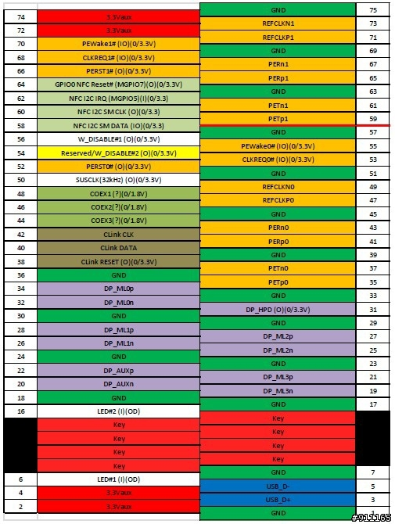
(Figure M2-A, the key in the pin8-pin15. With PCIe x2, NFC, Display Port and USB 2.0 channel, etc.)
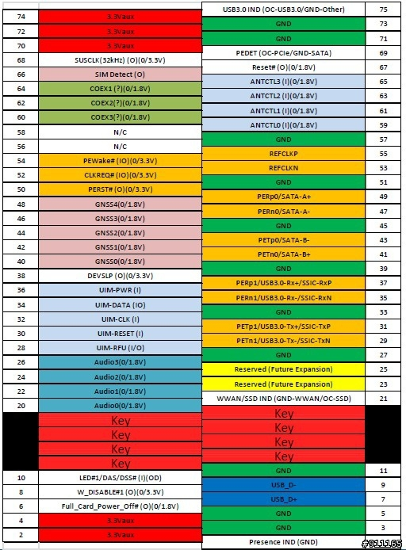
(Figure M2-B, the key in the pin12-pin19. With SIM card, audio, PCIe 2.0, SATA and USB 3.0 channel multiplexing channel, etc.)
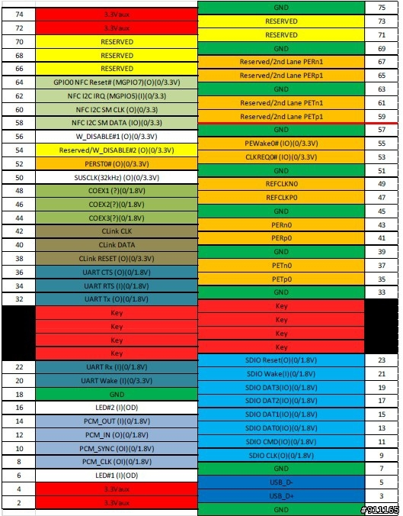
(Figure M2-E, the key in the pin24-pin31. With PCIe x2, NFC, SDIO, PCM, USB 2.0 channel, etc.)
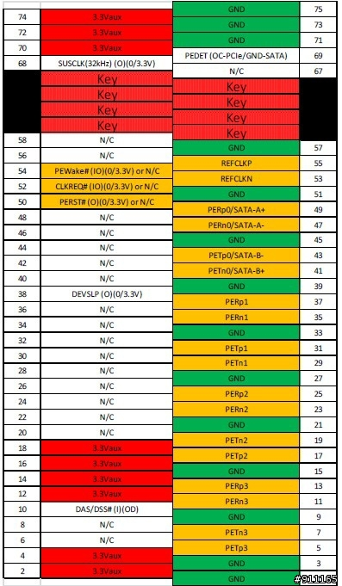
(Figure M2-M, the key in the pin59-pin66. With PCIe x4 and SATA multiplex channel)

